# Conflict Scenario

## **Review**

### Interpersonal Conflict Management Styles

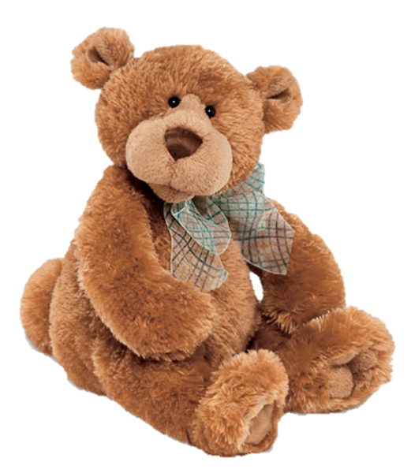

[CC 2.0 BY Matthew](https://www.flickr.com/photos/falcon1961/3304306800/)

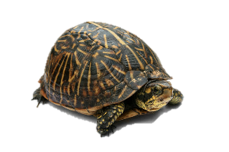

[CC SA 3.0 Unported BY Jonathan Zander](https://en.wikipedia.org/wiki/File:Florida_Box_Turtle_Digon3.jpg)



[CC 3.0 BY Superawesomevectors](https://superawesomevectors.deviantart.com/art/Shark-Cartoon-Free-Vector-Illustration-643399222)



[CC0](https://pixabay.com/en/urban-lost-hiding-afraid-1002149/)

Low to High Concern for Other

Concern for Self

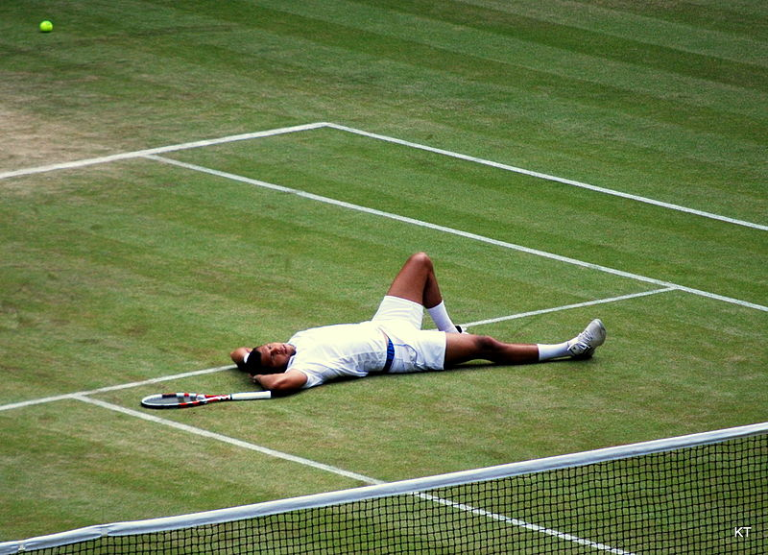

CC SA 2.0 Generic BY [Carine06 from UK](https://commons.wikimedia.org/wiki/File:Flickr_-_Carine06_-_%22I_give_up.%22.jpg)



CC 2.0 BY [Zabara Alexander](https://www.flickr.com/photos/zabara_tango/6955720271)

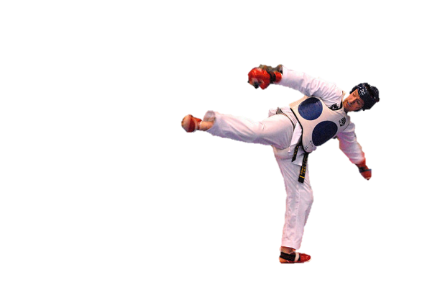

[CC0](https://commons.wikimedia.org/wiki/File:US_Army_53525_Soldiers_compete_in_Tae_Kwon_Do_tournament_for_Warrior_Country_level.jpg)

### **Interpersonal Conflict Resolution**

The following diagram shows a process that can be followed when trying to resolve interpersonal conflict.

### Listening

A considerable proportion of our communication involves listening, yet little attention is devoted to improving listening. HURIER is an acronym for tips that can be used to improve listening.

### “I” Phrases for Conflict Resolution

The “I” phrase is used during conflict resolutions to avoid attacking others. Open the conversation with a statement in first person, passive voice: “I feel … when … because … I would like …”

Adapted from (Dwyer 2012, p. 40)

## **Student Name and ID:** Joshua Tenchavez – 12105542

## **Student Name and ID:** Joshua White – 12196075

## **Scenario**

Find a partner. Read the scenario below. Choose one partner to be Joe Bloggs, and the other to be Jane Doe. Together, answer the following to help prepare you for the role play.

## **Scenario: Joe did not complete a task by the deadline**

Joe and Jane are working on a report that is due today. Joe was assigned the task of writing the executive summary. Unfortunately, Joe has not completed the task.

What is the most appropriate conflict management strategy for Jane to use in this situation? (Choose one)

Compete/Force

Compromise

Avoid/Withdraw

Collaborate/Confront

Accommodate/Smooth

Why did you choose the above conflict management strategy?

This take needs to be complete however both Joe and Jane should complete the task together that way both are working towards the goal.

Shouldn’t compete or avoid as it’s a group task and the group can get penalized for no work from certain members.

### **Listen and Understand**

How could Jane start the conversation?

How did you go with your part?

Describe the purpose of the discussion. Describe the conflict. What questions could Jane ask to determine Joe’s perspective of the situation?

“To ensure that Joe has done his work or will be able to finish it before the end of the

day, however, Joe has not. Hence Jane should ask Joe about how it happened and try to understand his point of view as well as asking if he needs any help with the work.”

Write sentences that features the “I” phrase, such as in the example below:

“I feel *[your feeling]* when *[their behaviour]* because *[effects on you]*. I would like *[alternative behaviour]*”.

“I feel let down when you can’t complete the task because it negatively impacts my result. I would like to work together on this task to complete it in time.”

Invent a reason why Joe did not complete the executive summary by the deadline.

“I had other priorities at the time and therefore could not complete the work.”

How could Jane paraphrase Joe’s reason for missing the deadline to ensure that she understands Joe’s perspective?

Joe had other important tasks to do and completed them before attempting the task

### **Empathise**

Now that Jane understands Joe’s perspective, how could Jane empathise with Joe? Write a response that shows that Jane identifies with Joe’s emotions.

“I understand that you feel bad and embarrassed that you couldn’t complete the report. I also understand that there can be a lot of outside factors effecting your commitments to the task. I agree, it can be difficult to balance these factors.”

### **Apologise**

Include an apology if it is appropriate.

“Sorry I couldn’t do it. I’ll try harder next time.”

### **Offer Solution**

What question could Jane ask to help build Joe’s involvement with potential solutions?

“Anything I could help with?”

Come up with a way for Jane and Joe to settle on a solution.

Joe works with the help of Jane to complete the report. That way Joe is contributing to the outcome which still completing it in time with help.

### **Resolution**

How could Jane resolve the conflict? Jane needs to ensure that Joe agrees. Write a response that outlines appreciation for the solution.

“How about we work together on this report to get it done in time, that sound good?”

“Yeah, that sounds like a good idea.”

“Thank you for doing this.”

### **Reconciliation**

How could Joe reconcile the relationship and let Jane know that she is important to him?

“You were a great help in completing this task, I really appreciate everything you do for me and I don’t know where I would be without you. How about we grab a bite after this is over, on me.”

How can Jane let Joe know she is listening while Joe is talking?

Smile, nod and respond in pauses in a way that does interrupt Joe.

What could Jane do if Joe started to withdraw from the conflict at any stage?

Make sure he knows she wants what’s best for both of them and that she wants to help him succeed.